MEDESS
A Methodology for Designing Expert Support Systems

My name is Jim van Weelderen, born in 1964. I started my study Informatica in 1982 at the Delft University of Technology.
After my first encounter with Henk Sol in 1984 I felt inspired. In his unique way Henk brought business and technology together in both a conceptual and practical way. I decided to conduct my MSc research and PhD research under his supervision.

In 1991 I completed my PhD research with Henk. In the four years preceeding this great milestone I had dedicated my time in exploring how to support true experts by making appropriate use of IT.  Unfortunately I cannot share the summary of my thesis as I cannot find the floppy disk on which I have saved it in WordPerfect for the last time more than 25 years ago. Please bring a visit to the Delft University of Technology library and ask the librarian for MEDESS, a Methodolgy for Designing Expert Support Systems. It is a blue book with a small red ribbon and from the outside very similar to 12 other PhD theses completed back then by my fellow Kongsi friends. | 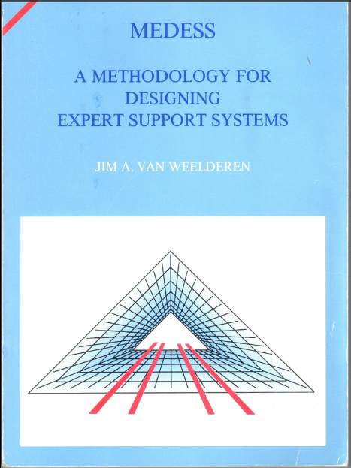

In the 1980’s personal computing was the upcoming trend in IT. Knowledge intensive organizations started exploring the opportunities of this new concept. It soon became clear that to really benefit from this technology push one has to explore its application and implementation in an intelligent and realistic way.
My PhD thesis adresses what a problem is and how humans solve problems. The (ill-)structuredness of a problem is merely attributable to who is up to solving the problem instance, the novice who has no clue or the expert who can actually see the right solution without conducting any inference. These insights are essential to make appropriate use of IT to support (collaborating) experts.

To reflect upon the value of my PhD research after 25 years is a subjective exercise, it depends upon who you ask.

If you ask me personally I now see the my PhD research as the valuable jump start of my professional life.  Essentially Henk has learnt me two insights. The first is the power of conceptualization i.e. quickly come to the essence of a situation by adressing with all stakeholders the right elements on through abstraction and simplification.  The second is the power of planning and execution i.e. in a transparant and controlled way work towards an outcome which satisfies all stakeholders.  Nowadays it is unimaginable not to follow an agile approach due to the frequently changing business and legal circumstances my customers operate in. Back in the mid 1980’s I remember Henk initiated a course called Prototyping parallel to our more conventional System Analysis and System Design classes.  Thank you Henk! | 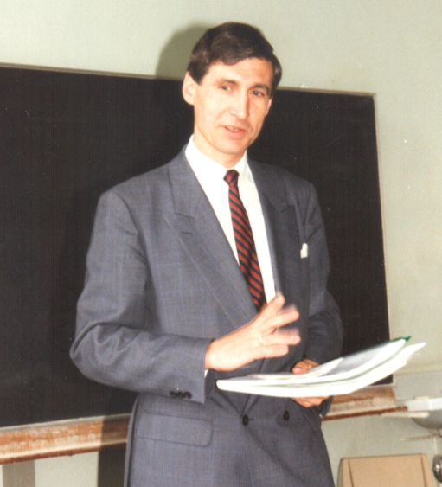  

After my PhD research I founded my company which specialized in implementation of custom Expert Support Systems. Many knowledge intensive organizations, both profit and non-profit, have consulted me for various reasons to help leverage their expert assets. The framework of the PhD thesis has contributed significantly in guiding my customers how to think about their challenges. Adressing the reason why for innovations (systelogical problem) not only from a micro-perspective but also by seeking improvements in internal and inter-organizational collaborations (meso- and macro-perspective). Thereby following an agile approach has made it possible for customers to adopt and benefit from progressing insights in a budget controlled way. Back then this proposition brought tremendous value to the table.
I am not sure of the scientific value of my PhD thesis. I have no clue if my work later on has been referenced by anyone scientist in any scientific research. Perhaps Henk can shed some light on this?

