Reference Models for Industrial Automation
Dr.H.M. Böhms
Delft University of Techology, June 1991

1. Initiation, Research question and Research approach
Initiation
In the world of industrial automation or, using a buzzword from 1991, “Computer Integrated Manufacturing (CIM)”, many concepts, terms, definitions, views and technologies existed. There was a need to bring order in both the conceptual and technical complexity not to say chaos.
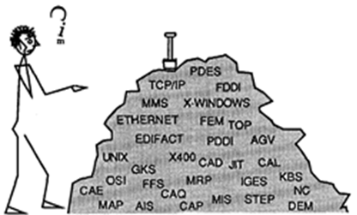

Research Questions
What Framework (as ‘meta-model’) and Reference Architecture (as ‘blueprint’) can be defined to bring order in CIM and help industry to introduce and benefit from CIM concepts and solutions? Sub-question: Can we define a language or ‘CIM Base Model’ to define both the Reference and organization-specific Architectures?

Research Approach
The following steps were taken:
1. Analysis of the CIM world in 1991
2. Specification of a descriptive CIM Framework
3. Specification of a prescriptive CIM Framework
4. AS-IS modelling for the two selected use cases
5. TO-BE modelling for same use cases
6. Specification of CIM Base Model and Reference Architecture (by abstraction)
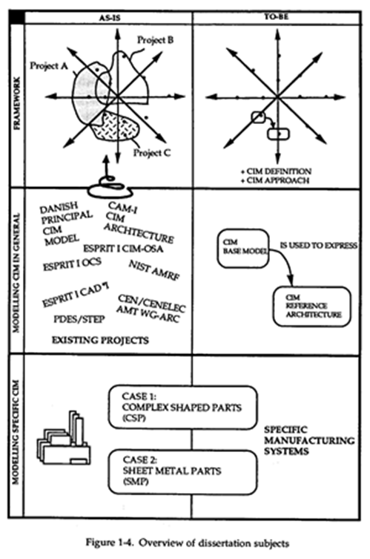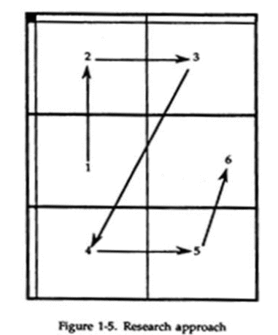

2.Contributing to a body of knowledge
The body of knowledge that was relevant in 1991 for this research was related to the topic of “Enterprise Modelling” and “Product Modelling”. The enterprise modelling was typically divided in three levels:
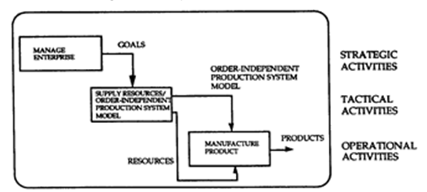
Worldwide and European standardization bodies addressed these modelling areas. A good example was the CIM-OSA (Computer Integrated Manufacturing Open System Architecture) initiative. At that time I had many interesting and successful discussions with this European Esprit CIM-OSA project (see i.e. https://en.wikipedia.org/wiki/Computer-integrated_manufacturing#CIMOSA).

Furthermore, there was a close link with Product Modelling for which the standardization was at that time covered by ISO 10303 (“STEP”; the Standard for the Exchange of Product model data).

3. Exploring a field
Via active participation in:
- ISO TC184/SC5/WG1
- CEN/CENELEC AMT WG-ARC
And deep analysis of all relevant initiatives at that time:
Some examples:
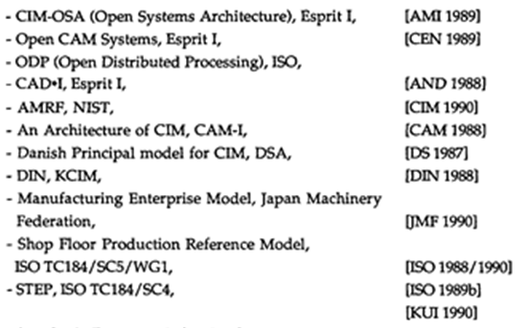
4. Creating a generic understanding
First two main meta-dimensions where identified (‘Language’ and’ Epistemology’). The first one reflects that you need a language to define a model but also a language to define that language properly etc.; the second one defines the various meta-levels in modelling from instances to data structures/knowledge to meta-info. Clearly these dimensions are fully orthogonal.

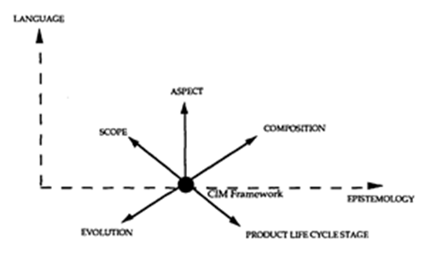
The thesis then focusses on one specific point in this main framework referred to as the CIM Framework introducing five more modelling dimensions relevant.
The dimensions were used to analyse existing CIM approaches but also define a proposed CIM approach (see next chapter).

5. Developing a contribution
A prescriptive multi-dimensional CIM Framework
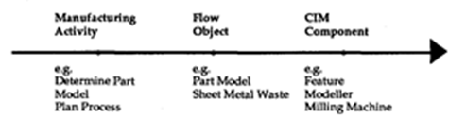
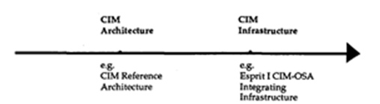
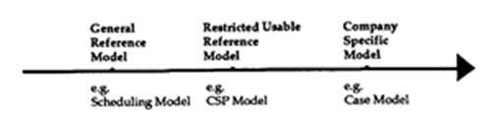

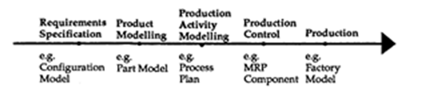
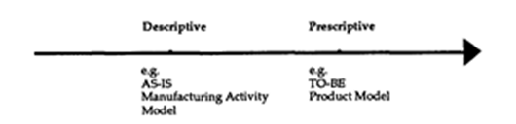
Applied in four steps for instantiation:
      - Describe the AS-IS situation (as ‘baseline’)
      - Describe the Problems/Issues/Opportunities
      - Define the TO-BE situation(s)
      - Evaluate the TO-BE situations(s)

6. Instantiation
Complex Shaped Parts: Lips Ship Propellers (Drunen, NL)
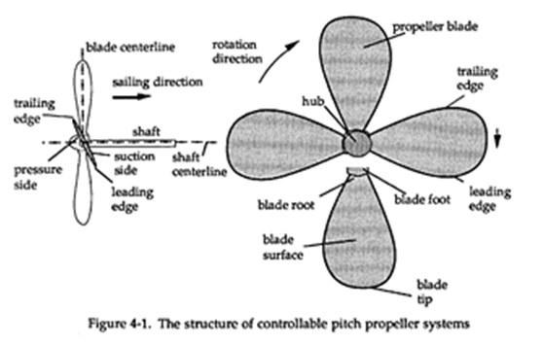
Sheet Metal Parts: Elevator components
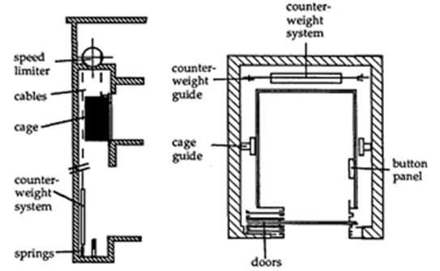

7. Evaluation
Benefits in design/part modelling
- 3D (Product) Modelling is essential for complete/accurate modelling.
- Only relevant when right interfaces to design software functionalities (like FEM and simulations) are present.
- Direct support of open standard like STEP avoids inefficient/ineffective transformations.
Benefits in production
- 3D-measuring and 5-Axis milling machines will be the future (replacing complex casting and unhealthy grinding processes)
Generic Benefits
- The framework is sufficient to define both the CIM Base Model and Reference Architecture; which on their turn bring order in the CIM chaos and help industrial organizations to apply and benefit from CIM.

8. Epilogue
- The applied recursive RS-IS paradigm is as relevant as ever.
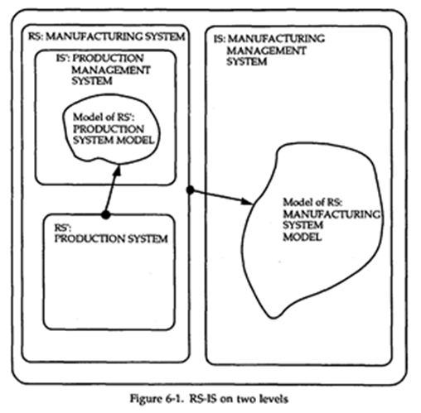
25 years later, it is still THE starting point for determination of the right context/scope for any automation issue in industry.
- As part of my proposed CIM Base Model I defined a Manufacturing System Definition Unit (MSDU):
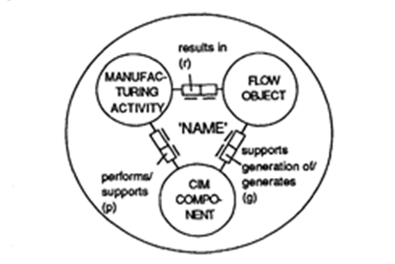
Again 25 years later, people are still struggling with the integrated modelling of business activities, mechanisms and controls for those activities and the physical and information flows resulting from those activities. We now often use OMG’s Business Process Modelling Notation (BPMN) when modelling processes which can be seen as an improvement of IDEF-0 at that time.
- The product modelling in NIAM has been taken over by UML and Linked Data (LD)/Semantic Web (SW) technology (RDF/RDFS/OWL/SPARQL) and the compliant implementation side (development and deployment) has enormously matured since then. STEP technology is still used in e.g. the construction sector (like by buildingSmart International IFC). The web has become THE information infrastructure partly explaining also the growing success of LD/SW.
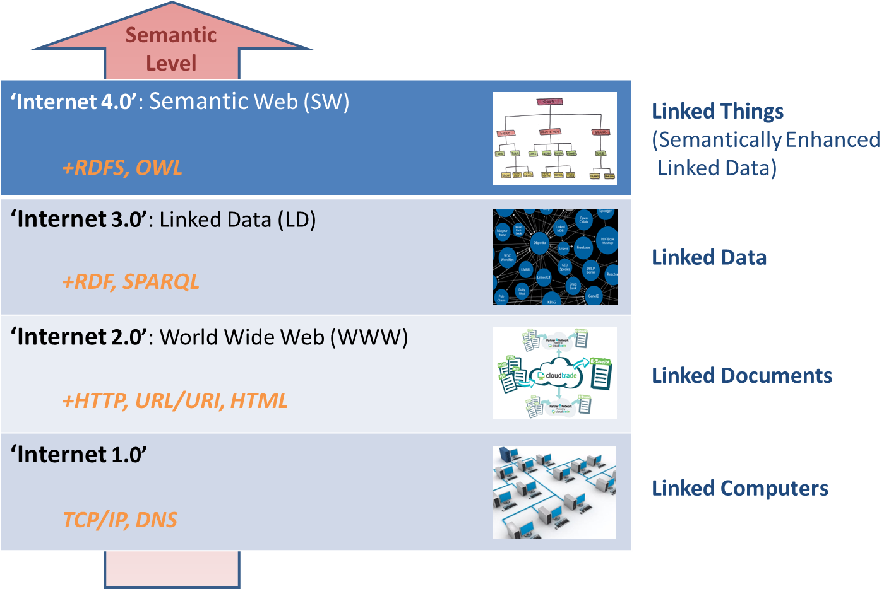
- 3D measuring is now everywhere known as 3D scanning devices, not just for objects but up to the scale of building spaces and even urban areas.
- The 5-axis milling machine of the future is now making its comeback as a kind of inverse, 3D printing in a variety of materials.
- The second proposition of the thesis identified Specialization and (typical) Decomposition as primary abstraction mechanisms. Today these are still the most basic and important modelling mechanism available (forming the backbone/hierarchy of modern ontologies in the form of taxonomies resp. meronomies).
- The same is true for the identified “Required, Proposed, Realized” dimension. Nowadays a big issue is the ability to link together the client requirements, the proposed solutions and the actual situations, the latter available via the Big Data provided by the upcoming Internet of Things (IoT).
- It is interesting to see that although the issues addressed and applied concept are as relevant as ever, the actual terms and acronyms used changed considerably.
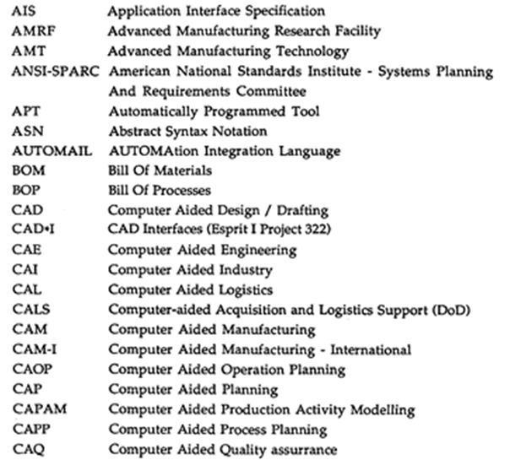

The Future of integration and data (or “what are we researching right now in 2016”)
The future of integration and the role of big, smart and open data in it seem bright. The future of generic advanced software code (Genetic Algorithms, Artificial Neural Networks with deep learning, optimization and simulation) might be even brighter. We can hardly imagine what will happen when these data and code developments become entangled, strengthening each other and their combined link with the ‘real‘ world via the upcoming Internet of Things.
In the past we have seen several generations of technologies especially in the integration area. First ISO STEP would solve it all. The technology was fine but they got stuck in the modelling with it. BuildingSmart International (bSI), formerly known as the International Alliance of Interoperability (IAI), filled that gap with the Industry Foundation Classes (IFC), at least for the construction industry sector (actually only for the modelling of buildings, expanding as we speak towards civil infrastructures like roads and railways). In the meantime technology shifted towards XML and Web Services (SOAP and “RESTful over HTTP”) and now we hit the Semantic Wave and Big Data movement.
Some people observing cynically might ask “So what’s next?” There will indeed always be a next but still this time with linked data and semantic web technology there is a feeling that this approach is somehow inevitable. Having its fundament in logic, being a layer on top of the very successful (non-semantic) web as we known it and most of all its generic domain-independent applicability are some good arguments for this.
Future binding with advanced generic code will further strengthen its position as the future of data.
Recurrent modelling patterns are emerging like for quantities and units, decomposition, default values, requirements, meta-data and universal high level archetypes like Objects (natural and artefacts), Spaces, Networks (for transport of traffic, energy, information etc.), Locations according to agreed coordinate systems etc.
Besides the earlier discussed LD protocol stack, the following variant is often used.
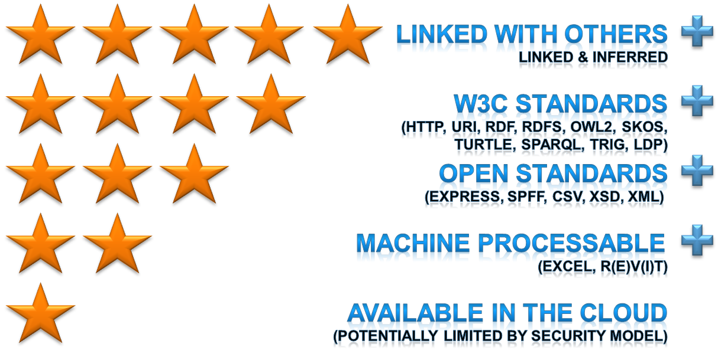
In my current work at TNO I start any new integration or data modelling initiatives with a ‘five star’ ambition and aim to add yet an star for semantic alignment of modelling patterns and guidelines for issues that will further boost the semantic wave:
- Standard decomposition (maybe combined with the functional and (function-fulfilling) technical view on an object (already in in 1991 referred to as the “hamburger Model” by Wim Gielingh).
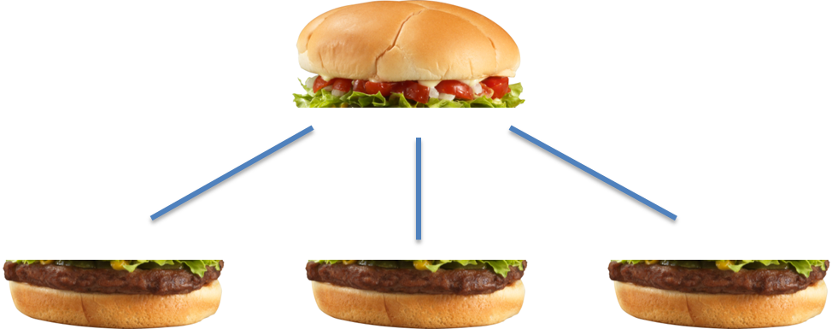
- Universal Quantity and Unit modelling
- A proper ‘default value’ mechanism for both attributes and relationships
- Standard meta-info mechanism (beyond the now semantically ignored annotations) for classes, properties, datatypes, restrictions, individuals and/or, on ‘lower’ level, triples
- Formalization of (currently ad hoc extensions for) Named Graphs to fully align RDF and SPARQL (see [Named Graphs]) probably promoting the TriG syntax form (Turtle extended with graph meta-concept)
- OWL extension with SHACLE for complex constraint modelling in closed world situations
- Improved end-user experience in editing (like support for generic and ontology-aware drag and drop visual instantiation) and publishing (like full Semantic Wiki generation)

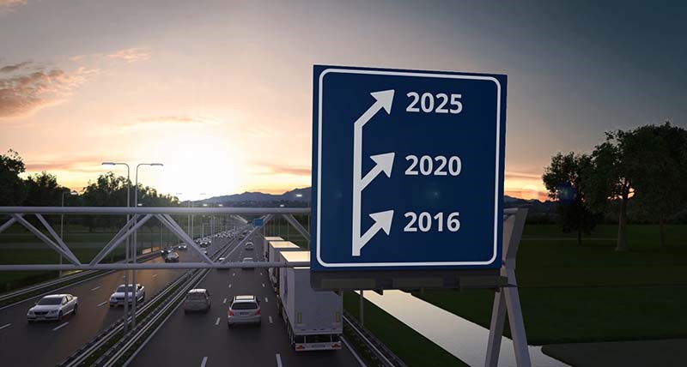
2016: The current state-of-the-art (RDF/RDF/OWL2/SPARQL).
2020: Improved generic semantic data and knowledge modelling and associated software support for development and deployment (SHACLE, QUDT, Quads, improved meta-modelling and rules, next generation triples/quad stores and associated reasoners).
2025: Automated semantic data acquisition via full Internet of Things (IoT) integration. Full integration with generic advanced code capabilities like simulation, Genetic Algorithms and Artificial Neural Networks aka a true “Object-Oriented” Semantic Web.
Assuming the software industry comes up with 100%-compliant and scalable editing, publishing, collaboration and deployment software tools not just for the data but also for the semantic web application development, we will see a future not only for the Internet of Things but especially for the Internet of Data and Knowledge, the Internet of Everything actually.

