Digital Governance In Support Of Infrastructure Asset Management
Dr. Thinus Bekker
University of Groningen, March 2016

1. Initiating, Research Question and Research Approach
Organisations and countries are globally relying on infrastructure investment and the performance of existing infrastructure assets, to improve economic growth and the quality of life of citizens. Infrastructure asset management aims to address the lack of timely investment in infrastructure and the inadequate maintenance of existing infrastructure assets. Evidence-based strategic asset management decision making is at the core of infrastructure asset management. It requires relevant and harmonised quality asset information from IT and control systems.
This research was initiated based on a business need at the base case, Rand Water, to make strategic infrastructure asset management decisions, using asset information from both the IT and control system landscapes. A number of real-world problems were identified that could prevent the successful enablement and support of strategic infrastructure asset management decision making in a sustainable manner. These problems relate to: 1) the collection and transformation of asset information into useful and reliable evidence for asset decision making; and 2) the implementation of a sustainable change in asset information management and digital governance.
A new way of thinking, working, controlling and modelling was required, in relation to digital governance and asset information management, in order to resolve these problems.
An appropriate approach was also required to implement the new way of asset information management and digital governance in a sustainable manner for a large complex heterogeneous organisation, such as Rand Water.

The research questions to be addressed by this research are:
- What is the content of a digital governance approach that addresses the information requirements of a modern infrastructure asset management philosophy and the associated problems?
- What is the appropriate approach to implement enterprise-wide digital governance in a sustainable manner for a large, complex, heterogeneous asset intensive organisation?
The researcher is a reflective practitioner whose reflections induced the artefact (i.e. the Rand Water Way) that was designed for, and instantiated at, the base case. Design science was used as a research philosophy and a pragmatic epistemological stance was adopted. The design science research philosophy was effectuated with the inductive-hypothetic research strategy, in order to formulate and test a tentative hypothesis (i.e. the Rand Water Way design). The acceptance of the Rand Water Way was tested by illustrating its usage, as well as evaluating its perceived usefulness and usability.

Contributing to a body of knowledge
The research contributes to descriptive knowledge by increasing the knowledge and understanding of: 1) the associated problem domain; and 2) the relevant concepts and theories related to the research. It contributes to theory and prescriptive knowledge related to the field of information management and digital governance, as applied to large and complex infrastructure asset intensive organisations. The contribution primarily addresses:
1) how digital technology and information should be viewed, managed and governed, in order to support infrastructure asset management; and 2) the required characteristics of an approach to successfully implement this new way in a large, complex, infrastructure asset organisation. It was achieved through the design and instantiation of an identifiable and unique artefact, namely the Rand Water Way, as the answer to the two research questions. The Rand Water Way instantiation at the base case further contributes to the fields of information management, digital governance and transition management at a practical level.
The Rand Water Way is a unique artefact. It addresses the gap in literature regarding:
1) digital governance in control system environments; 2) enterprise-wide digital governance for industrial organisations that includes IT and control systems; and 3) an approach to implement enterprise-wide digital governance in a large complex infrastructure asset intensive organisation. The Rand Water Way goes beyond IT governance, IT management, information management and compliance to any specific standard, code or framework. The uniqueness of the Rand Water Way is primarily in its integration and encapsulation of the individual concepts and theories into a single integrated approach that focuses on digital governance in support of strategic infrastructure asset decision making in large and complex infrastructure asset intensive organisations. Each of the integrated constituent parts are required to make its contribution to the holistic solution of the problem. Some of the specific unique characteristics of the Rand Water Way include: 1) a two-tier hierarchy for the prioritisation of controls, consisting of an essential centralised controls tier and an important federated controls tier; and 2) a flexible transition roadmap, consisting of continuous phases that focuses first on building trust, secondly on exploiting efficiency improvement opportunities at an acceptable level of risk, and finally on formalisation of the digital environment.

Exploring a field
Some of the key observations from literature that influenced the design of the artefact are: 1) infrastructure asset management is becoming more formalised and sophisticated, which increases the need for quality asset information to make asset decisions; 2) the management of information includes related disciplines and activities, such as information security and information governance; 3) the digital technology environment of an infrastructure asset intensive organisation typically includes both IT systems (e.g. ERP) and control systems
(e.g. SCADA, LIMS); 4) the risk of IT and control systems technology incompatibility is decreasing, but enterprise architecture remains an important discipline to manage complexity and change in an organisation; 5) it is unclear to what extent IT governance has been applied in asset intensive organisations or to control system environments; 6) there is a trend to define and implement internal IT governance frameworks, by tailoring one or more commercially available frameworks based on the characteristics of the organisation;
7) compliance to a standard or legislation is an important and common reason for organisations to implement IT governance; 8) there is a trend to follow an holistic approach to IT governance, that addresses both governance and operational level processes and controls; 9) it is recognised that the implementation of IT governance is a change initiative, rather than a technology initiative; 10) a successful implementation approach makes use of associated disciplines and mechanisms, such as project management, maturity models and transition roadmaps; and 11) implementation approaches are tailored for the specific discipline and organisation to ensure a successful transition during the long and difficult road.

Creating a generic understanding
Rand Water is the base case for this research. It is the largest water utility in Africa and provides more than 12 million people in the economic heartland of South Arica with
4,183 Ml/d of world-class potable water. Its source of raw water is 70 kilometer (44 miles) away from the bulk of the consumers. The water must also be lifted 366 meters from the source to its destination. One of Rand Water’s key characteristics is its dependence on its infrastructure assets. The replacement value of the infrastructure assets is ZAR 80 billion. The aging infrastructure of Rand Water is one of its key risks. Rand Water plans to spend ZAR 13 billion on its infrastructure between 2015 and 2019. The management of infrastructure assets is a key success factor of the organisation in the achievement of agreed service levels with customers. The digital environment of Rand Water includes both IT systems and control systems. The digital functions are segregated. There is one corporate IT function and two control system functions.
The problems extracted from the base, Rand Water, and generalised through literature review, include: 1) the ever increasing size and complexity of digital technology and asset data; 2) digital technology incompatibility and isolation; 3) information security threats, due to the integration of IT and control systems; 4) inadequate digital governance of control system environments; 5) the inconsistent maturity of digital governance between the IT and control system environments; 6) inadequate assurance, due to a pure compliance objective; 7) the organisational segregation of IT and control system functions in large and complex infrastructure asset intensive organisations; and 8) resistance to change by digital functions. The resolution of the generalised problems of the digital environment of a large and complex infrastructure asset intensive organisation forms the basis of the requirements of the artefact. In order for the artefact to be useful and usable, it needs to address the technology and information, process and people related problems.

Developing a contribution
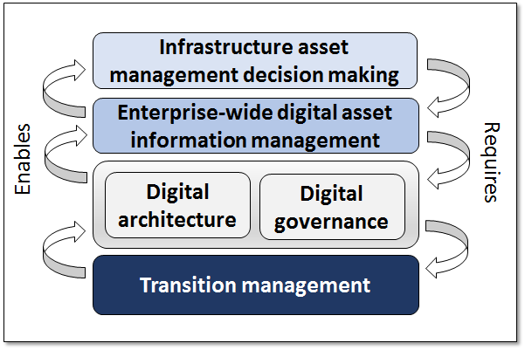
The artefact, namely the Rand Water Way, is an integrated enterprise-wide approach for the governance and management of asset information and the associated underlying digital technology, including IT and control systems. It is also an approach to introduce and implement this new way of thinking, working, controlling and modelling at an infrastructure asset intensive organisation. The overall philosophy of the Rand Water Way is that effective infrastructure asset management requires asset information to be managed, governed and utilised as an enterprise-wide resource. This requires: 1) an enterprise-wide digital architecture; 2) an optimal degree of enterprise-wide digital governance and operational process controls; and 3) the implementation of this new way of thinking, working, controlling and modelling in relation to asset information management and digital governance, in a sustainable manner.
The Rand Water Way embodies this philosophy through its five overlapping and integrated constituent parts. These are: 1) strategy - to obtain formal commitment for the approach and to direct the rest of the constituent parts; 2) information management - the management of asset information from IT and control systems as a valuable enterprise resource;
3) architecture - the enterprise-wide digital architecture and standards related to asset information and digital technology; 4) governance - the integrated, appropriate and enterprise-wide digital governance and operational process controls for asset information and digital technology; and 5) transition management - the approach for introducing and implementing the change in a sustainable manner.
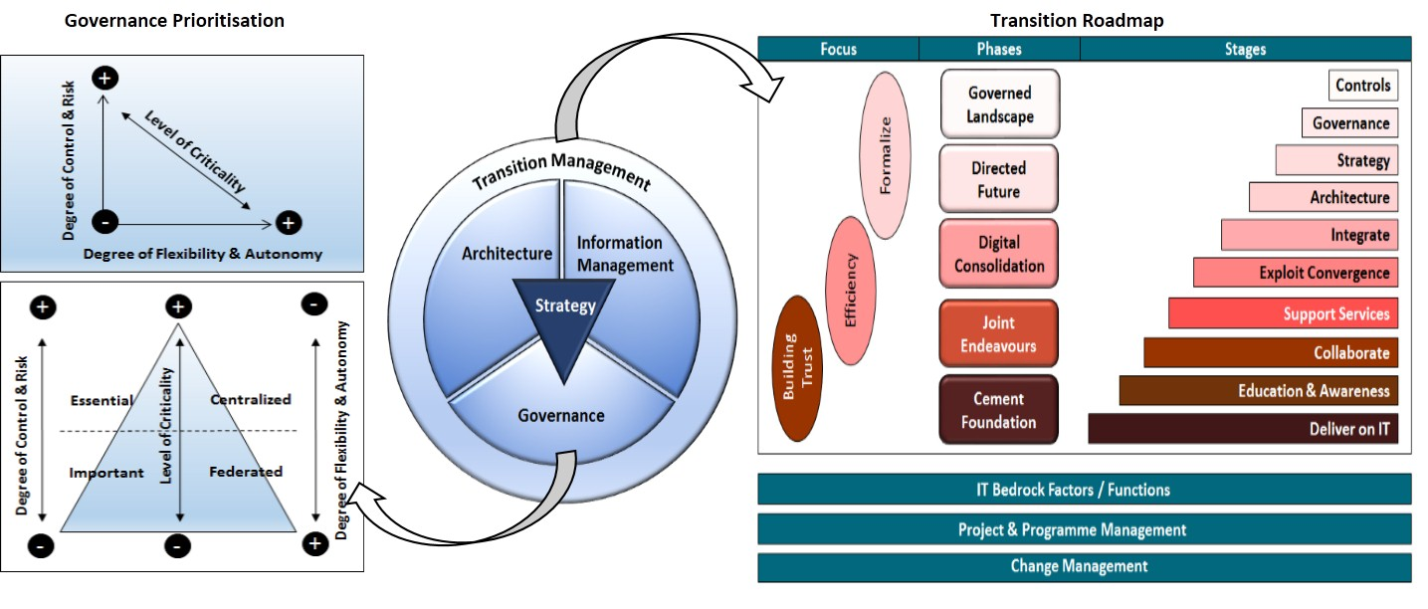
All the constituent parts are relevant and required to provide a holistic solution to the problem. However, this research focused primarily on the contribution of the governance and transition management constituent parts, because these two constituent parts address the two research questions directly.

Instantiation
The Rand Water Way was operationalised and is currently being used in practice at Rand Water. The Rand Water Way was instantiated by: 1) contextualising it based on the Rand Water characteristics; 2) obtaining acceptance and approval from the authorised governance structures; and 3) implementing it across the three digital functions of the organisation. A co-created strategy was formalised and approved by the board of Rand Water. An enterprise architecture was created, that included IT and control systems. An enterprise information management framework was created and applied to asset information from across the digital landscape. An enterprise-wide digital governance framework was established and integrated into the corporate governance framework.
The appropriate digital governance mechanisms and operational process controls were selected and prioritised, based on the result of a risk assessment. The emphasis of the essential governance mechanisms were placed on the enterprise-wide digital governance framework, policies, digital compliance framework, relevant digital strategies, risk management framework, and a common management process control framework foundation.
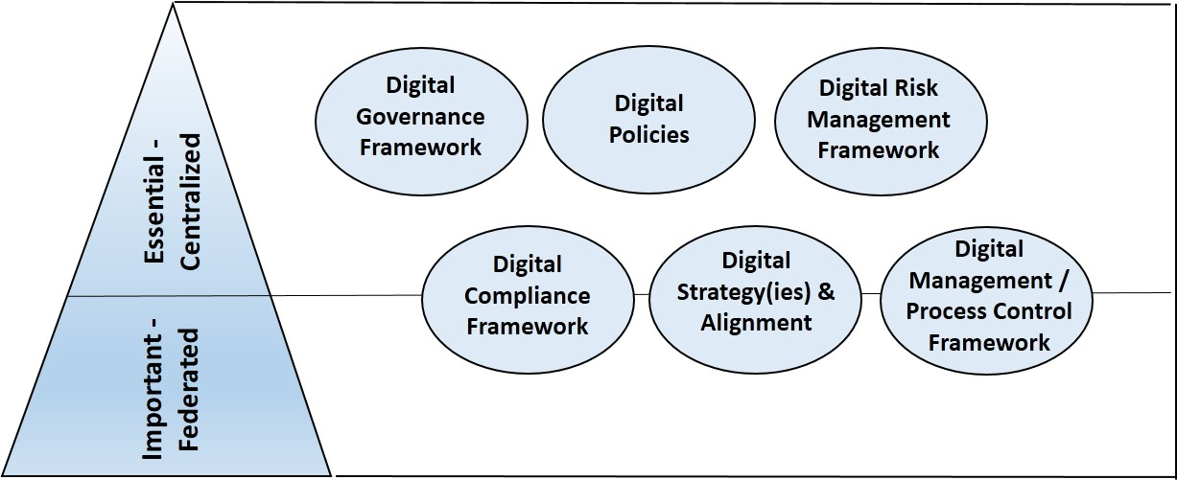
The emphasis of the essential operational process controls were placed on the converged digital infrastructure, information security, architecture, common strategic risks and information management.
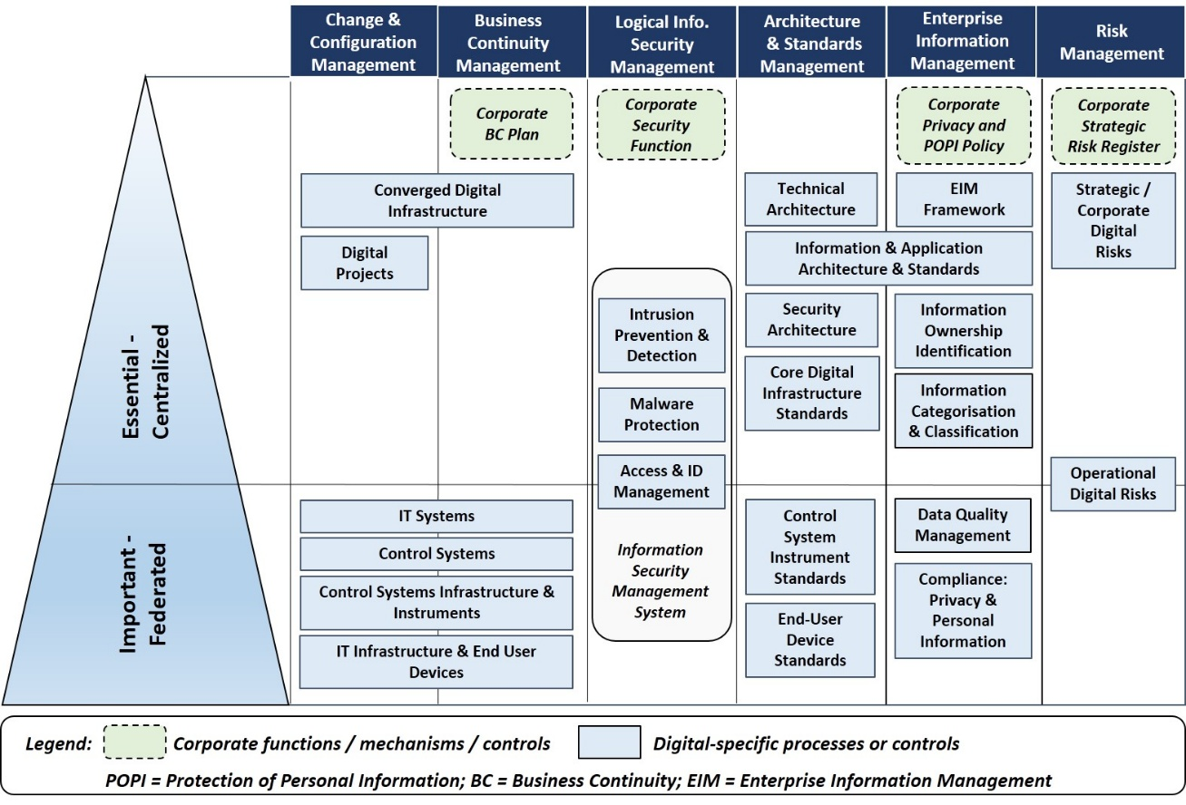
A transition roadmap was defined and implemented for Rand Water, in order to successfully introduce and embed the change to the way of thinking and working. It includes the phased roadmap and the supporting work streams. The phased roadmap specifies all the initiatives required to improve the maturity of enterprise-wide digital governance from an ad-hoc to a formalised situation. It focuses first on building trust between the digital functions
(e.g. delivering a quality IT service, education, collaboration), then on delivering on efficiencies (e.g. support services, convergence, integration), before it focuses on formalisation of the environment (e.g. architecture, strategy, and governance).
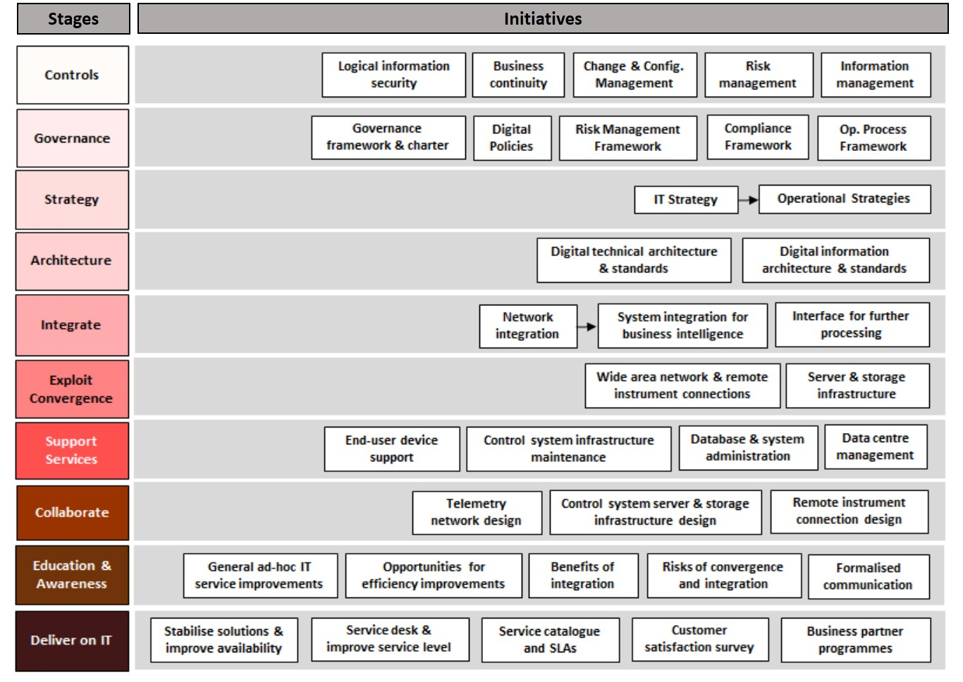
The supporting work streams include program management, bed rock factors and organisational change management work streams. Both the “hard” and “soft” factors required for a successful transition are addressed. Rand Water received value from this implementation in terms of: 1) improved digital security; 2) improved collaboration between digital functions; 3) cost savings by exploiting the convergence in technology; 4) a cost effective digital governance solution that effectively mitigates the related risks; and 5) the ability to integrate asset information from IT and control systems on a continuous basis, and in a safe and secure manner.

Evaluation
The acceptance of the Rand Water Way was tested at Rand Water and at nine similar organisations. These nine organisations represented the mining, water, manufacturing and logistics industries, as well as both the public and private sectors. The perceived usefulness and usability of the Rand Water Way was evaluated at Rand Water. The potential perceived usefulness and usability, of a contextualised Rand Water Way approach, was evaluated at the nine similar organisations. The evaluation at the similar organisations tested: 1) the degree of generalisability of the Rand Water Way; and 2) the acceptance of the Rand Water Way for organisations that are at least as large and complex as Rand Water.
The result of the evaluation was positive for both the Rand Water evaluation and the evaluation at the nine similar organisations. The results showed that: 1) the problems originally extracted from the base case and generalised from literature, are prevalent at large and complex infrastructure asset intensive organisations across different industries and sectors; 2) the Rand Water Way is useful to Rand Water, because it effectively addressed their problems and delivered value; 3) the Rand Water Way has been adequately generalised, in order for a contextualised version to potentially be useful to large and complex infrastructure asset intensive organisations across different industries and sectors; and 4) the Rand Water Way is “easy to use” by, and appropriate for, asset intensive organisations across different industries and sectors. However, some of the large multi-national manufacturing and mining organisations in the private sector indicated that a significant degree of contextualisation is required, in order for the Rand Water Way to be useful to them. A number of the organisations that participated in the evaluation showed interest in adopting a contextualised version of the Rand Water Way.

Epilogue
This research originated from a real-world business need of the base case, Rand Water, namely: to make evidence-based strategic infrastructure asset management decisions using relevant harmonised quality asset information from both the IT and control systems. It addressed a number of real-world problems that could prevent the successful enablement and support of strategic infrastructure asset management decision making in a sustainable manner at Rand Water, as well as other infrastructure asset-intensive organisations. It applied a recognised, appropriate and rigorous research approach.
The research answered both the research questions posed at the start of the research. The artefact, the Rand Water Way, was operationalised, is used in practice at Rand Water, and provides value to Rand Water. The research contributes indirectly to society by enabling improved strategic infrastructure asset management decision making. It also directly contributes to descriptive knowledge, prescriptive knowledge and theory, as well as at a practical level via the Rand Water Way design and instantiation.
The research provides direction regarding future research. Examples of these are:
1) the adaptation, contextualisation and instantiation of the Rand Water Way, in order to address the information management and digital governance related problems being experienced by multi-national organisations with autonomous or semi-autonomous business units, each with their own infrastructure installations; and 2) the design and instantiation of an infrastructure asset management decision enhancement studio, focusing on strategic infrastructure asset management decisions for large and complex infrastructure asset intensive organisations, enabled by the Rand Water Way as a foundation.

